**Robert A. McDuckson - ITS Undergrad**

ITS 4750: Internet Engineering – Lab Report 02  
Tues September 12th @ 9am

1. Pre-Lab IP documentation table with student specific data filled in.

|  |  |
| --- | --- |
| **Name** | **Address** |
| WAN Address | 132.235.160.230 |
| LAN 1 Network | 100.70.200.0/26 |
| LAN2 Network | 100.70.200.64/26 |
| LAN3 – IntraNet | 100.70.200.240/28 |
|  |  |
| **LAN1 Subnet** |  |
| Net Number (/26) | 100.70.200.0/26 |
| VyOS-1 eth1 | 100.70.200.55 |
| VPCS | 100.70.200.10 |
| Ubuntu-GUI | 100.70.200.20 |
|  |  |
| **LAN2 Subnet** |  |
| Net Number (/26) | 100.70.200.65/26 |
| VyOS-2 eth1 | 100.70.200.100 |
| Ubuntu-CLI | 100.70.200.70 |
| Windows | 100.70.200.90 |
|  |  |
| **LAN3 Subnet** |  |
| Net Number (/28) | 100.70.200.220/28 |
| VyOS-1 eth2 | 100.70.200.240 |
| VyOS-2 eth2 | 100.70.200.250 |

1. For all four child VMs (the ones INSIDE GNS3), make a table to collate the following information:

a. What IP address was assigned it?  
b. What IP subnet mask was assigned it?  
c. What IP address was the router?  
d. What are the names of all the ethernet interfaces on the system?

|  |  |  |  |  |
| --- | --- | --- | --- | --- |
|  | **IP** | **Mask** | **Gateway** | **Interface** |
| VPCS | 10.70.200.50 | /26 | 10.70.200.2 | Eth0 |
| Ubuntu-GUI | 10.70.200.60 | /26 | 10.70.200.3 | ens160 |
| Ubuntu-CLI | 10.70.200.70 | /26 | 10.70.200.4 | Ens192 |
| Windows | 10.70.200.80 | /26 | 10.70.200.5 | NIC1 |

1. Traceroute Tree



1. Wireshark summary data from step 32.

No. Time Source Destination Protocol Length Info

421 8.045003 192.168.100.3 142.250.191.206 ICMP 74 Echo (ping) request

423 8.067734 142.250.191.206 192.168.100.3 ICMP 74 Echo (ping) reply

461 9.047941 192.168.100.3 142.250.191.206 ICMP 74 Echo (ping) request

464 9.076402 142.250.191.206 192.168.100.3 ICMP 74 Echo (ping) reply

495 10.051188 192.168.100.3 142.250.191.206 ICMP 74 Echo (ping) request

496 10.072698 142.250.191.206 192.168.100.3 ICMP 74 Echo (ping) reply

1043 19.934822 192.168.100.2 192.168.100.3 ICMP 74 Echo (ping) request

1044 19.935005 192.168.100.3 192.168.100.2 ICMP 74 Echo (ping) reply

1. Traceroute command output from step 55.

tracert -d google.com

Tracing route to google.com [142.250.191.206]

over a maximum of 30 hops:

1 <1 ms <1 ms <1 ms 192.168.100.1

2 12 ms 14 ms 3 ms 142.254.149.29

3 30 ms 23 ms 20 ms 24.95.87.105

4 16 ms 21 ms 13 ms 65.29.17.202

5 21 ms 13 ms 23 ms 65.29.1.34

6 25 ms 23 ms 23 ms 66.109.6.68

7 24 ms 25 ms 29 ms 66.109.5.136

8 29 ms 28 ms 18 ms 72.14.209.254

9 29 ms 30 ms 21 ms 216.239.56.7

10 40 ms 37 ms 38 ms 142.251.60.15

11 27 ms 26 ms 25 ms 142.250.191.206

1. Traceroute Wireshark with sections expanded from step 55 packet highlight/showing TTL.

No. Time Source Destination Protocol Length Info

95 1.355577 192.168.100.1 192.168.100.3 ICMP 134 Time-to-live exceeded (Time to live exceeded in transit)

Frame 95: 134 bytes on wire (1072 bits), 134 bytes captured (1072 bits) on interface \Device\NPF_{D0ACC550-B592-4DFE-97D4-15F97A1D5C56}, id 0

Ethernet II, Src: SuperMic_f4:30:69 (00:25:90:f4:30:69), Dst: IntelCor_3f:ea:ce (a0:36:9f:3f:ea:ce)

Internet Protocol Version 4, Src: 192.168.100.1, Dst: 192.168.100.3

Internet Control Message Protocol

Type: 11 (Time-to-live exceeded)

Code: 0 (Time to live exceeded in transit)

Checksum: 0xf4ff [correct]

[Checksum Status: Good]

Unused: 00000000

Internet Protocol Version 4, Src: 192.168.100.3, Dst: 142.250.191.206

Internet Control Message Protocol

Type: 8 (Echo (ping) request)

Code: 0

Checksum: 0xf6ae [unverified] [in ICMP error packet]

[Checksum Status: Unverified]

Identifier (BE): 1 (0x0001)

Identifier (LE): 256 (0x0100)

Sequence Number (BE): 336 (0x0150)

Sequence Number (LE): 20481 (0x5001)

Data (64 bytes)

1. Screen capture of GUI element (**NOT** a pic with your smartphone).

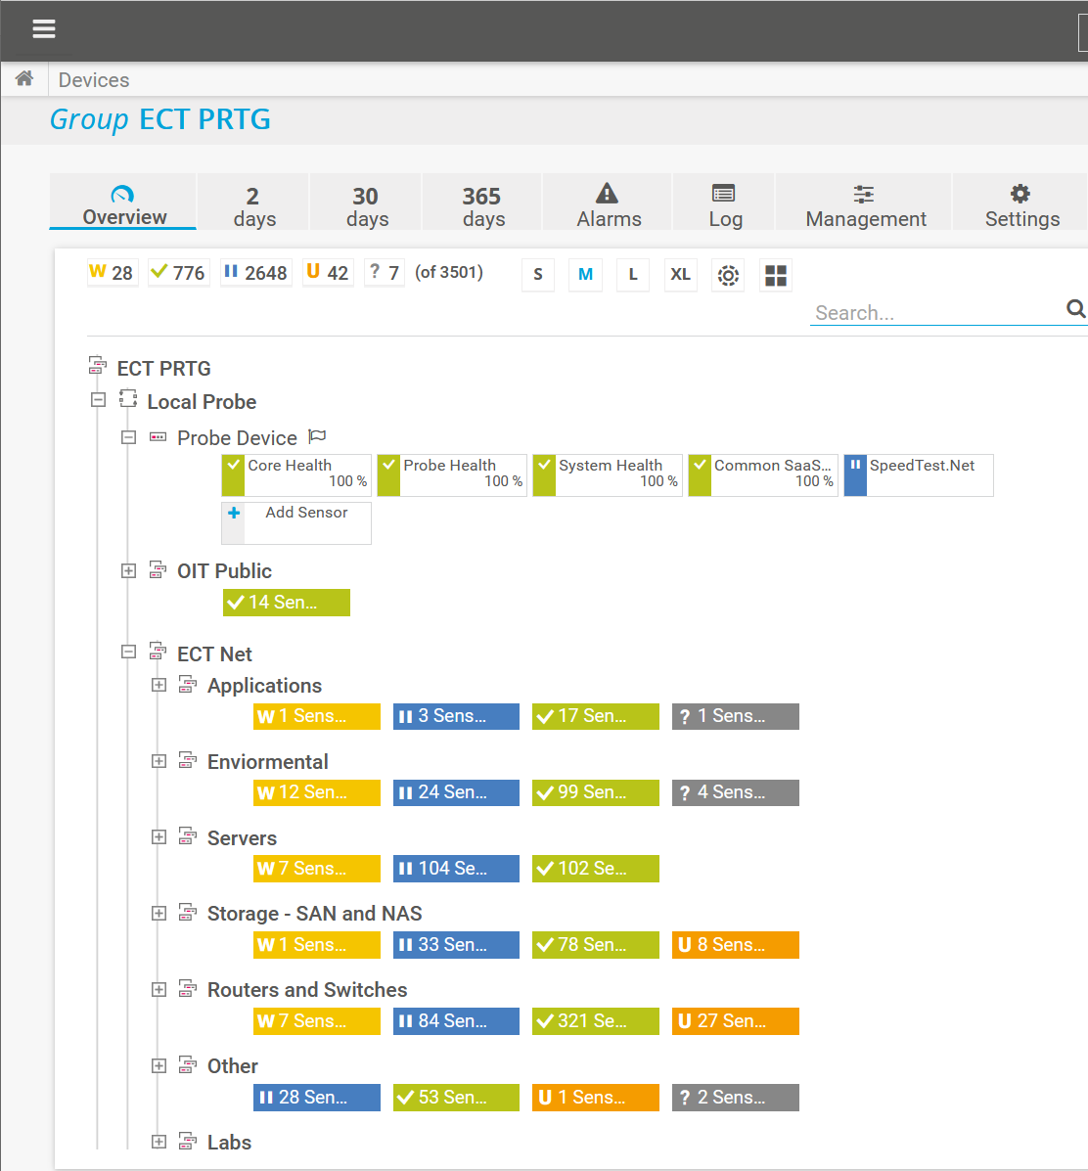

1. Explain the process of DHCP.

Lorem ipsum dolor sit amet, consectetur adipiscing elit. Maecenas ut lectus id justo porttitor tincidunt. Nulla facilisi. Integer nec purus metus. Nam pharetra auctor cursus. Suspendisse quis augue in sapien egestas porta at at nulla. Proin tincidunt finibus odio et lacinia. In quis varius dui, at egestas lacus. Duis in ante id elit ullamcorper euismod vel in lectus. Pellentesque congue tempor arcu vitae porta. In at nulla commodo, mollis sem sit amet, gravida nunc.

Maecenas euismod justo eget pellentesque semper. Nunc lorem arcu, ultrices sed volutpat sed, consectetur eu ipsum. Ut feugiat neque in feugiat ultrices. Praesent et felis convallis, dignissim eros vel, fringilla metus. Proin non interdum purus, a porttitor nisi. Sed sit amet ornare velit.

1. Network Diagram

